Jacobs Well Residents’ Association Committee Meeting
12th May 2021 8.00pm via Zoom
Agenda
Attendees : | Emma Raggett  David Snipp  Amanda Creese  Keith Witham  Sam Fisk  Nick Collett | Colin Shales  Ann Wright  Belinda Barrett
Apologies : | Bob McShee  George Lungley-Davison  Lisa Alderton  Heather Kidman  David Andrews
Chair: | Sam Fisk
Minutes: | Emma Raggett
Approval of previous month minutes. – Proposed Sam, Colin Second, all favour.

1.0 Guest speaker Joanna Christophides Weyside Urban Village
1.1 | Surrey County Council (SCC)  One of our local residents – John Osler of Burpham Court House, Woking Road - has kindly volunteered to research this. Accordingly, he needs to know how many Jacobs Well residents have this problem. He has asked that every local resident who has broadband speed of less than 10 Mbps should contact him by e-mail and he can then assess what the chances are of getting an improvement.  If you are happy to do this please could you send your e-mail and postal address inc postcode to him: johnosler81@yahoo.com He will do nothing without coming back to you for your views. | Cllr Keith Witham
1.2 | Guildford Borough Council  1. The Guildford sewage works will be relocated to the north east corner of Weyside Urban Village on the former land fill site of Slyfield industrial estate .There will be a pre-application consultation starting on the 24th of May to the 16th of July.  For more information contact: thameswater.co.uk/guildfordrelocation  2. Advance notice, Clay Lane will be closed and a diversion set up because a new water mains connection is required, and the diversion will be in place for approximately four days. This will take place during the next 12 months from the 1st of June. I will keep you further advised on this matter when I have more information.  3. The SANG Planning application is still under consideration.  4. The Leapale Road car park will be closed for the next 5 weeks. | Cllr Bob McShee
1.3 | Worplesdon Parish Council  Oak Processionary Moth nest Jacobs Well Recreation Ground  We have still not received formal notification about the spraying. Will we follow this up as soon as time permits.  White House pond maintenance licence  Draft Heads of Terms have now been received from Surrey County Council (SCC) Worplesdon Parish Council intends to challenge the proposed £100 per annum rent for maintaining the pond, equating to an overall charge of £1,000 over the term of the licence.  Rain garden installation, A320  Date of installation still not confirmed by SCC.  Replacement bus shelter, Woking Road  SCC have still not advised whether the Road Opening Licence has been obtained.  Bus shelter cleaning  Our Head Groundsman has again cleaned the wooden bus shelter on the Woking bound side of the A320.  Your Fund Surrey - £100,000,000 funding for capital community projects (Surrey County Council)  Worplesdon Parish Council has proposed two projects in Jacobs Well, which will require community support to move through the funding process.  - https://yourfundsurreymap.commonplace.is/comments/603f6aacdd744612a37f017a -Community Orchard for Harry’s Meadow.  - https://yourfundsurreymap.commonplace.is/comments/606584ac598bea022d62af75 - Re-wilding/additional native trees and shrubs - to improve biodiversity and to provide additional screening at the bottom of Harry’s Meadow (along the ditch line)  Residents wishing to support these projects need to click on the above links, scroll down to the bottom of the page and click on the pink ‘thumbs up’ icon.  Worplesdon Parish Council would greatly appreciate the support of the JWRA in respect of both of these projects. Please could the JWRA assist us by placing details of these projects on the JWRA Facebook page and in the next JWRA newsletter, if they have not already done so.  To date, only six people have supported the proposed community orchard and four people have supported the strategic planting of additional screening at the bottom of Harry’s Meadow. In order to progress these schemes, far more community support will be required.  CSW deployed in Jacobs Well on 05/05/21 – Jacobs Well Road  - Six motorists were caught exceeding the speed limit.  Play area repairs - Wetpour repairs required beneath the roundabout – Slip/trip hazard (main thorough fare) –  Quotations are being sought for the wetpour to be replaced due to the worsening trip hazard. Worplesdon Parish Council is also to consider installing a tarmac footpath into the play area from the main gate across to the roundabout for improved wheelchair access. The tarmac to include thermoplastic lining e.g. https://www.uni-play.co.uk/product_cat/characters-objects/  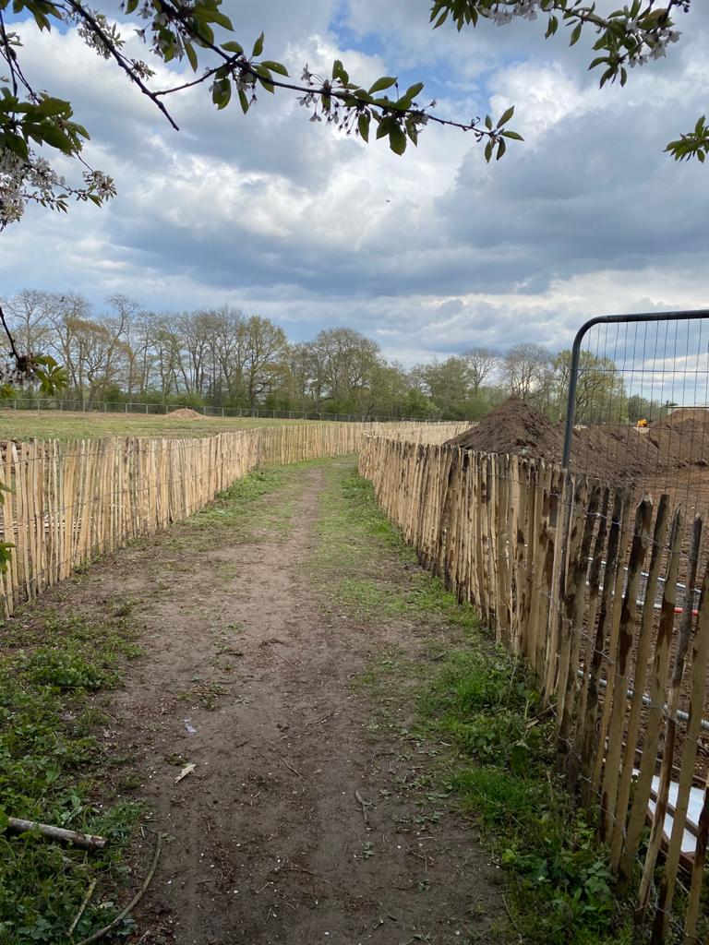  North Moors Allotment site  – the permissive right of way had to be closed off for a day for health and safety reasons. Worplesdon Parish Council has made a formal complaint to Guildford Borough Council about the spraying activity that took place during windy weather. The contractor is currently investigating the Parish Council’s complaint. | David Snipp/ Amanda Creese
2.1 Matters Arising [New or topical items raised to the JWRA since last meeting] All

2.2  2.3  2.4  2.5  2.6  2.7  2.9  3.0  4.0  5.0 | Subscriptions Belinda  – When should issue the envelopes and start collecting?  Distributors are happy to continue. Belinda to pull paperwork together to be collected in June.  White House Pond Amanda  Dealt with in the WPC update. Discussions still going ahead regarding the licence. Meeting at the end of June regarding the pond and trees in the surrounding areas.  Telephone box Amanda  Discussed at previous meetings, no up-take on re-purposing the space.  Dog Show Nick  Permit from WPC.  3rd Novelty dog show 4th September.  Need approval from WPC first before we move forward.  David Andrews proposed Emma Raggett second 4 for 1 abstained.  Discussion to be made at the June meeting regarding costs for the dog show.  Horse at the back of social club Emma  Note to be added to the newsletter regarding feeding the animals in the village.  Rats in the Village Emma  Sam and Belinda are also affected by rats. Emma to speak to Environmental health again and update everyone.  Post COVID – Coffee Morning? Amanda/Emma  As we come out of COVID we need to all find a new normal. Can we as a village hold an informal coffee morning to help people find their new normal and start socialising with people. To make this work all parties need to be evolved JWVH, JWRA and Social club. Add to the agenda for more discussion in May. Amanda to pull proposal together and speak to the other organisations to see if they are happy to join us.  Local Meeting & Forum Reports / Updates  Flood Forum – Any updates?  Standing Agenda Items  - Correspondence  - Newsletter content – On hold until COVID restrictions are relaxed.  - Facebook – SANG, Planting of trees, Grangefields, Allotment fences  - Website  JWRA Operation – Finances Update for April should be available from George and Lisa this month.  Village Life – Nothing to report  Village Calendar events 2021  - May – Mayday Fair – Heather Kidman – On hold until 2022  - June 2021 – Subscriptions  - 4th September – Dog Show – Nick Collett  - October - AGM  - December – Children’s Christmas party/Christmas market/carols – Emma Raggett  Previous meeting actions  Any Other Business?  End

